Git Workflows, Branching Strategy, and Code Reviews
This is a practical, industry-level guide covering how teams use Git in real projects (especially in backend + DevOps environments).

1. Git Workflow — Overview
A Git workflow defines how developers:
- Create features
- Collaborate
- Merge code
- Release software

Git Workflow Lifecycle

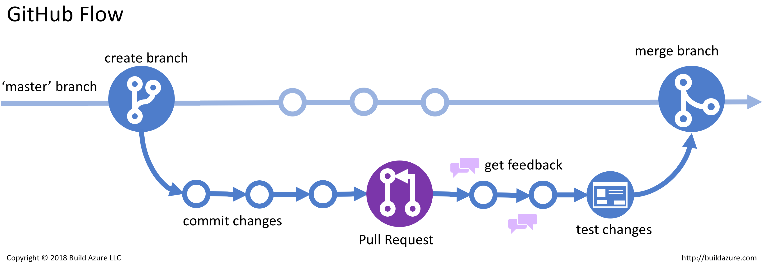

Flow
Clone → Create Branch → Commit → Push → Pull Request → Review → Merge → Deploy

2. Common Git Workflows
There are 3 widely used workflows:
- Centralized Workflow
- Feature Branch Workflow
- Git Flow Workflow

2.1 Centralized Workflow
All developers work on single branch (main/master).

Flow:
Clone → Commit → Push
✔ Simple
❌ Risky (conflicts, no isolation)

2.2 Feature Branch Workflow (Most Common)
Each feature is developed in a separate branch.

Feature Branch Workflow Diagram

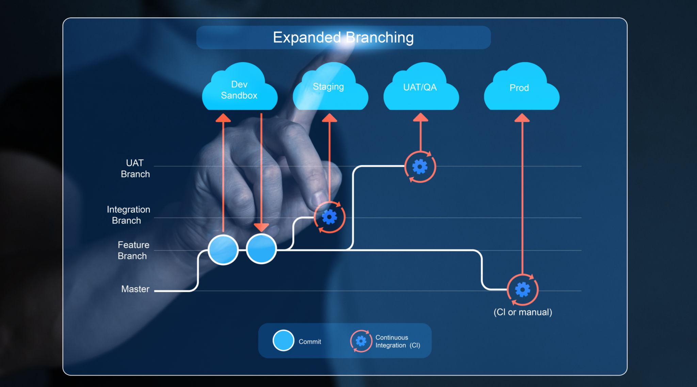

Steps
git checkout -b feature/login
git add .
git commit -m "Add login feature"
git push origin feature/login
Then:
Create Pull Request → Review → Merge → Delete branch
✔ Safe
✔ Scalable
✔ Used in most companies

2.3 Git Flow Workflow (Advanced)
Used in large enterprise projects.

Git Flow Branch Structure
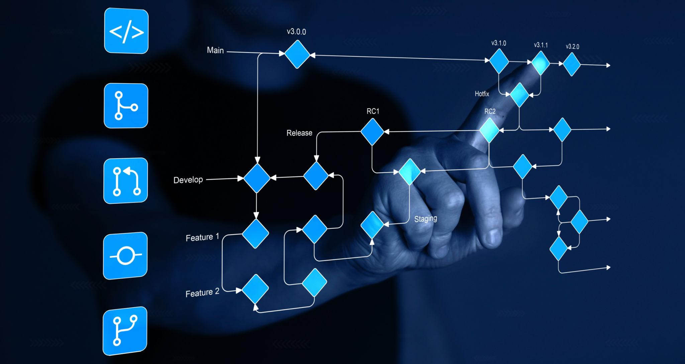


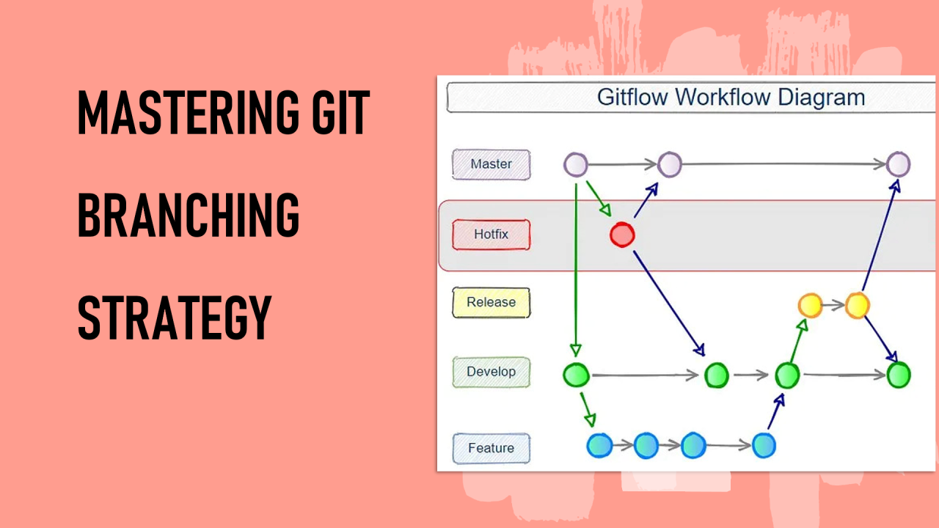

Branch Types
Branch | Purpose
main | Production code
develop | Integration branch
feature/* | New features
release/* | Pre-release testing
hotfix/* | Emergency fixes

Flow
feature → develop → release → main

3. Branching Strategy
A branching strategy defines how branches are created and merged.

3.1 Common Branch Types
main / master
develop
feature/*
bugfix/*
hotfix/*
release/*

3.2 Naming Conventions
feature/login-api
bugfix/null-pointer
hotfix/payment-failure
release/v1.0.0

3.3 Branch Lifecycle
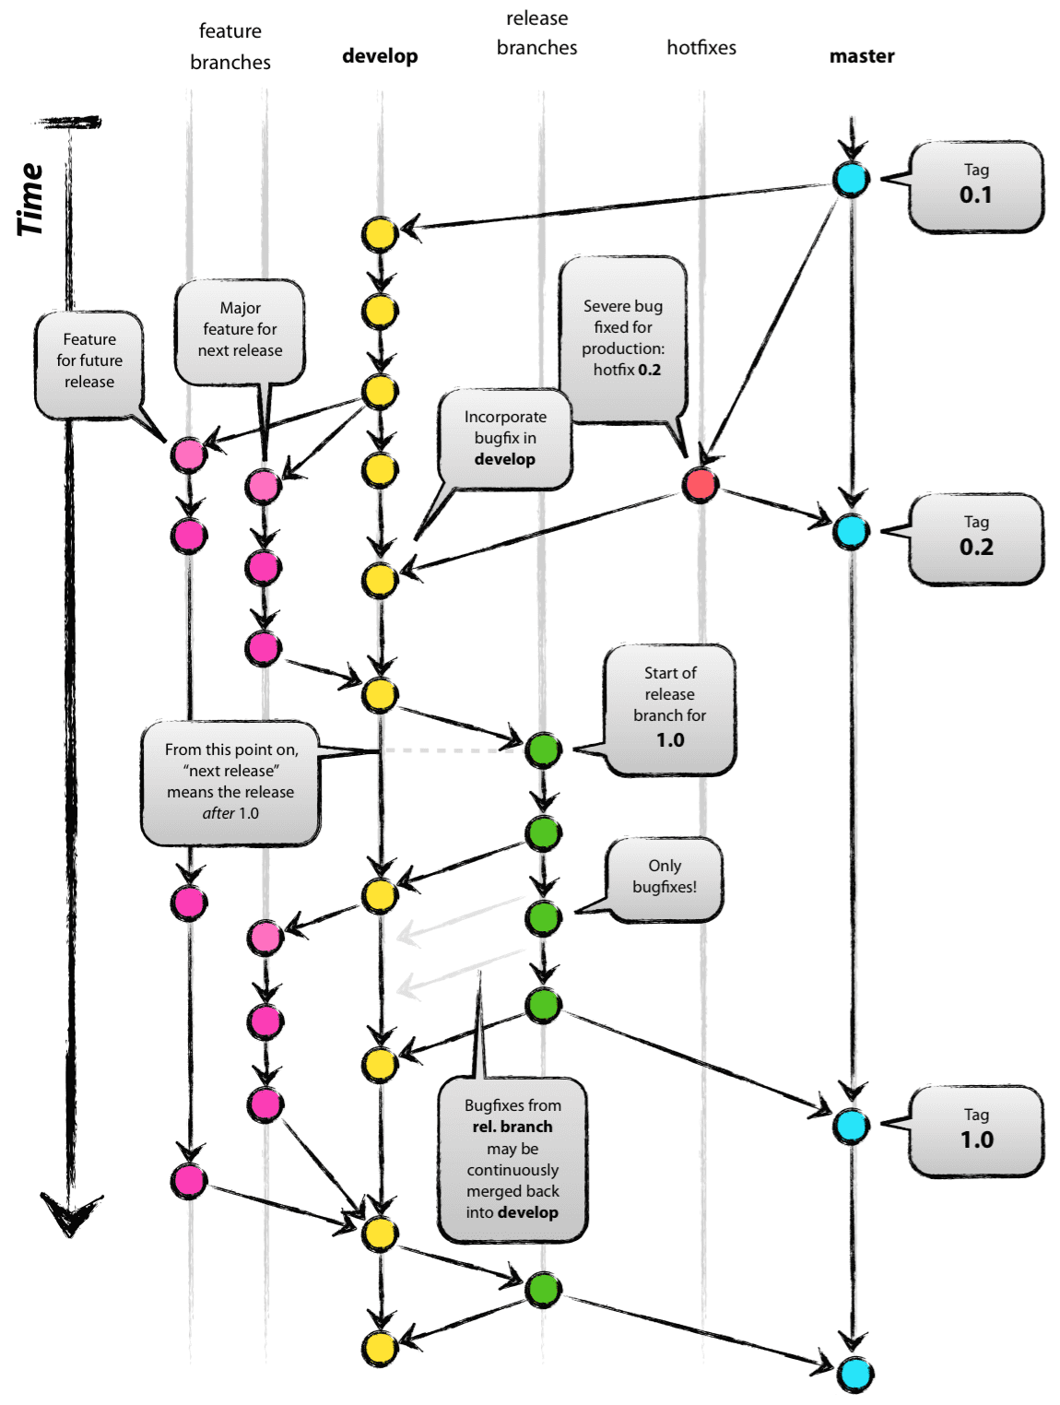
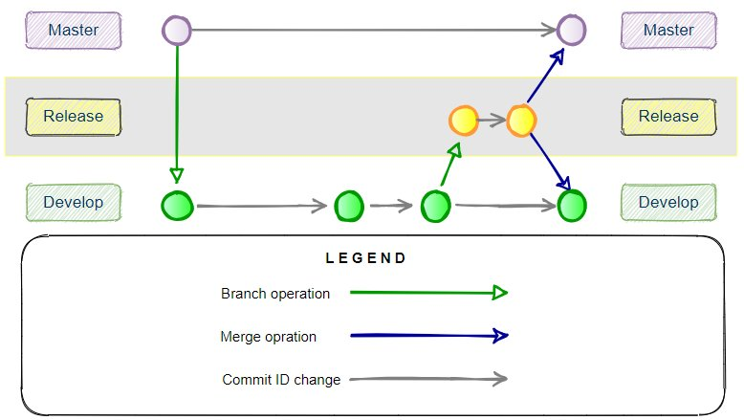
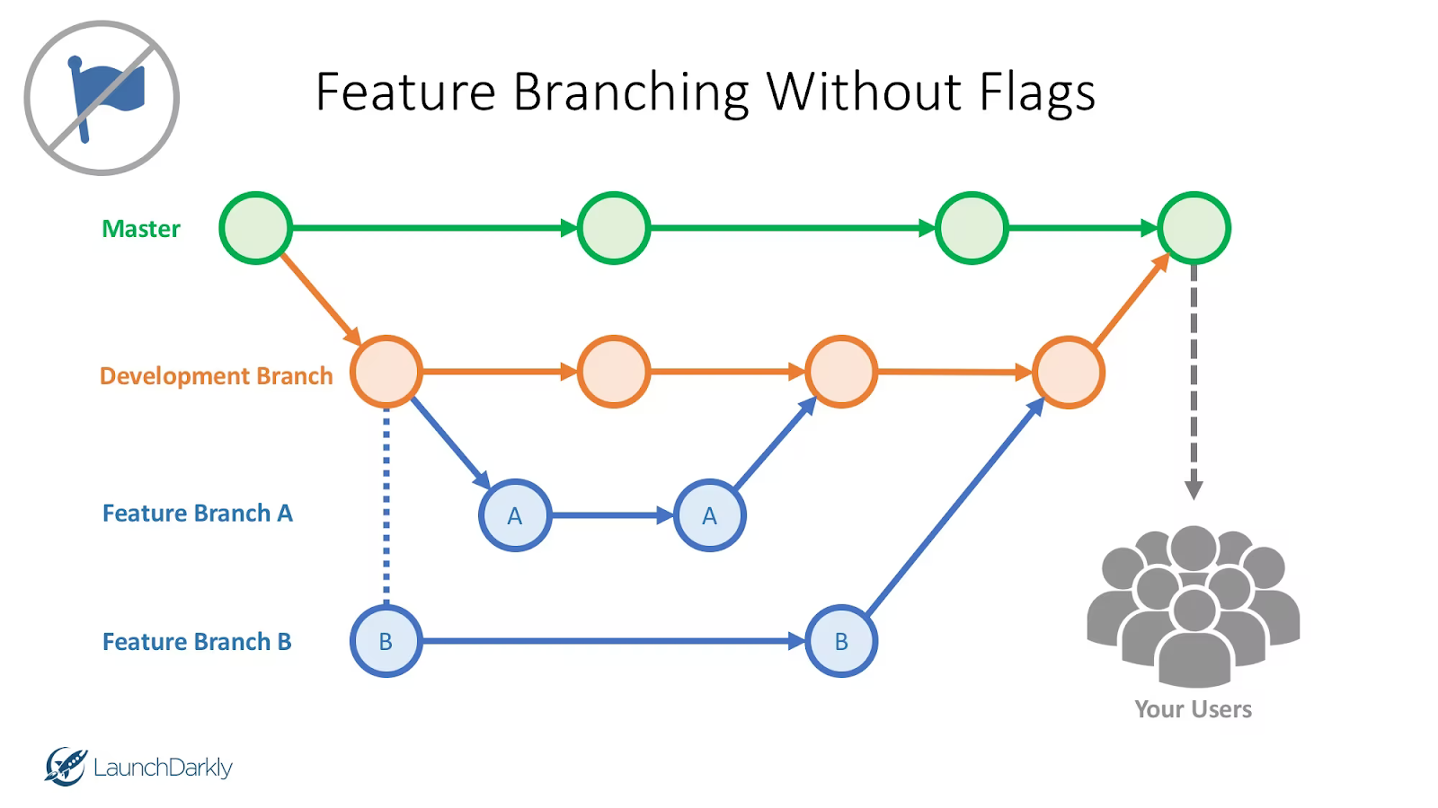
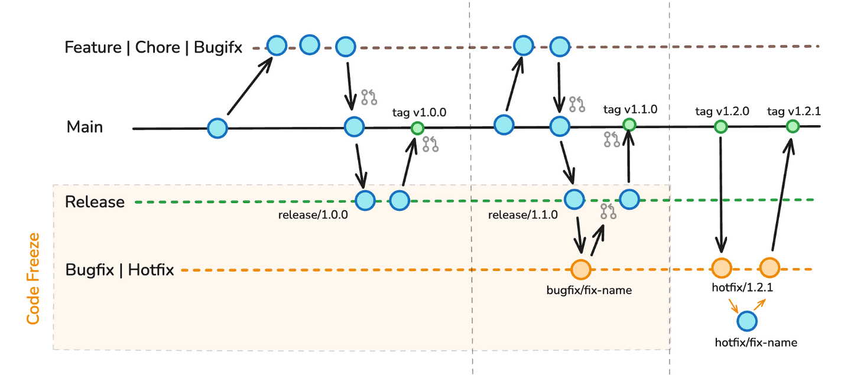

Lifecycle Steps
- Create branch
- Commit changes
- Push branch
- Create PR
- Review
- Merge
- Delete branch

3.4 Best Practices
✔ Keep branches short-lived
✔ One feature per branch
✔ Pull latest changes before working
✔ Use meaningful commit messages
Example:
git commit -m "Fix: NullPointerException in login service"

4. Pull Requests (PR) / Merge Requests
A Pull Request (PR) is a request to merge code into another branch.
Used in:
- GitHub
- GitLab
- Bitbucket

Pull Request Workflow
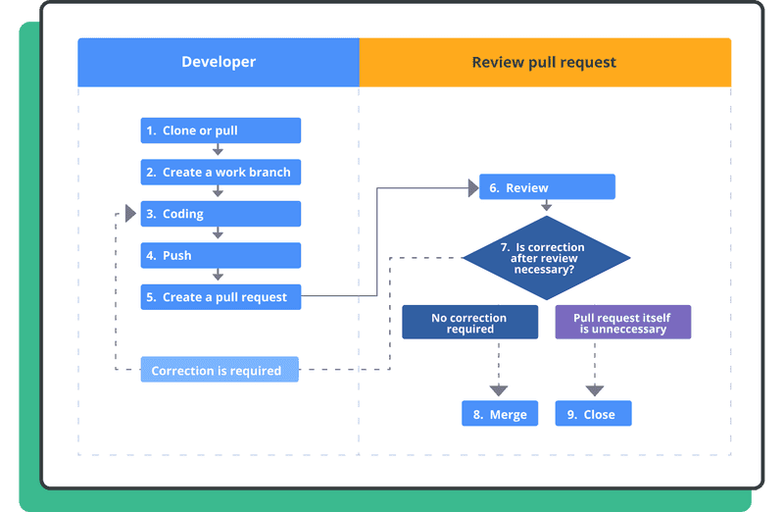
0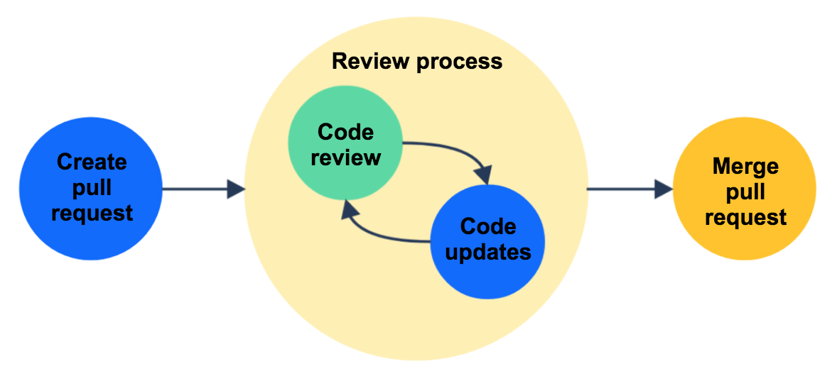
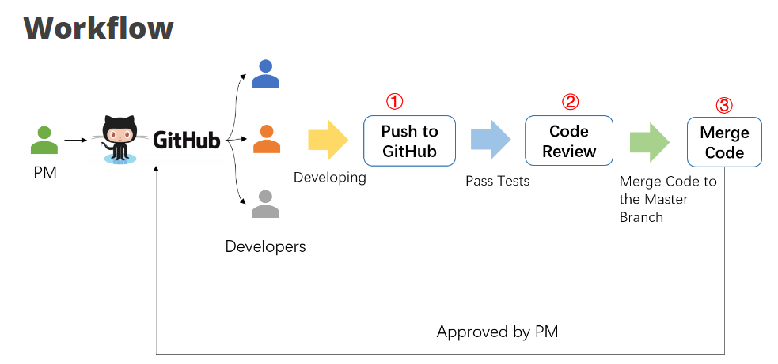
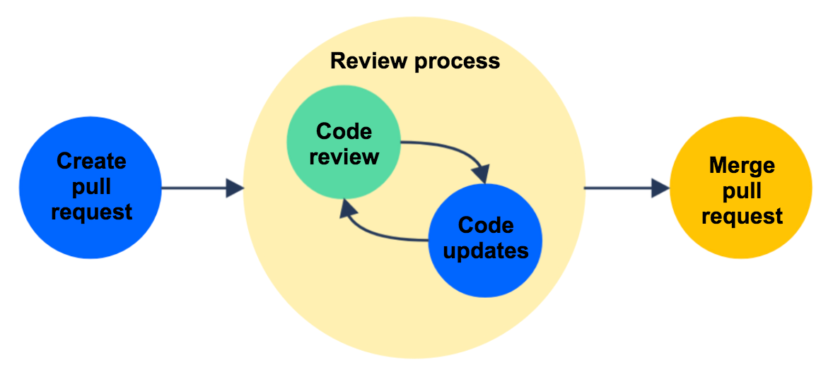

PR Steps
- Push feature branch
- Create PR
- Code review
- Approve changes
- Merge into main

5. Code Review Process
Code review ensures:
- Code quality
- Bug detection
- Best practices
- Knowledge sharing

Code Review Workflow
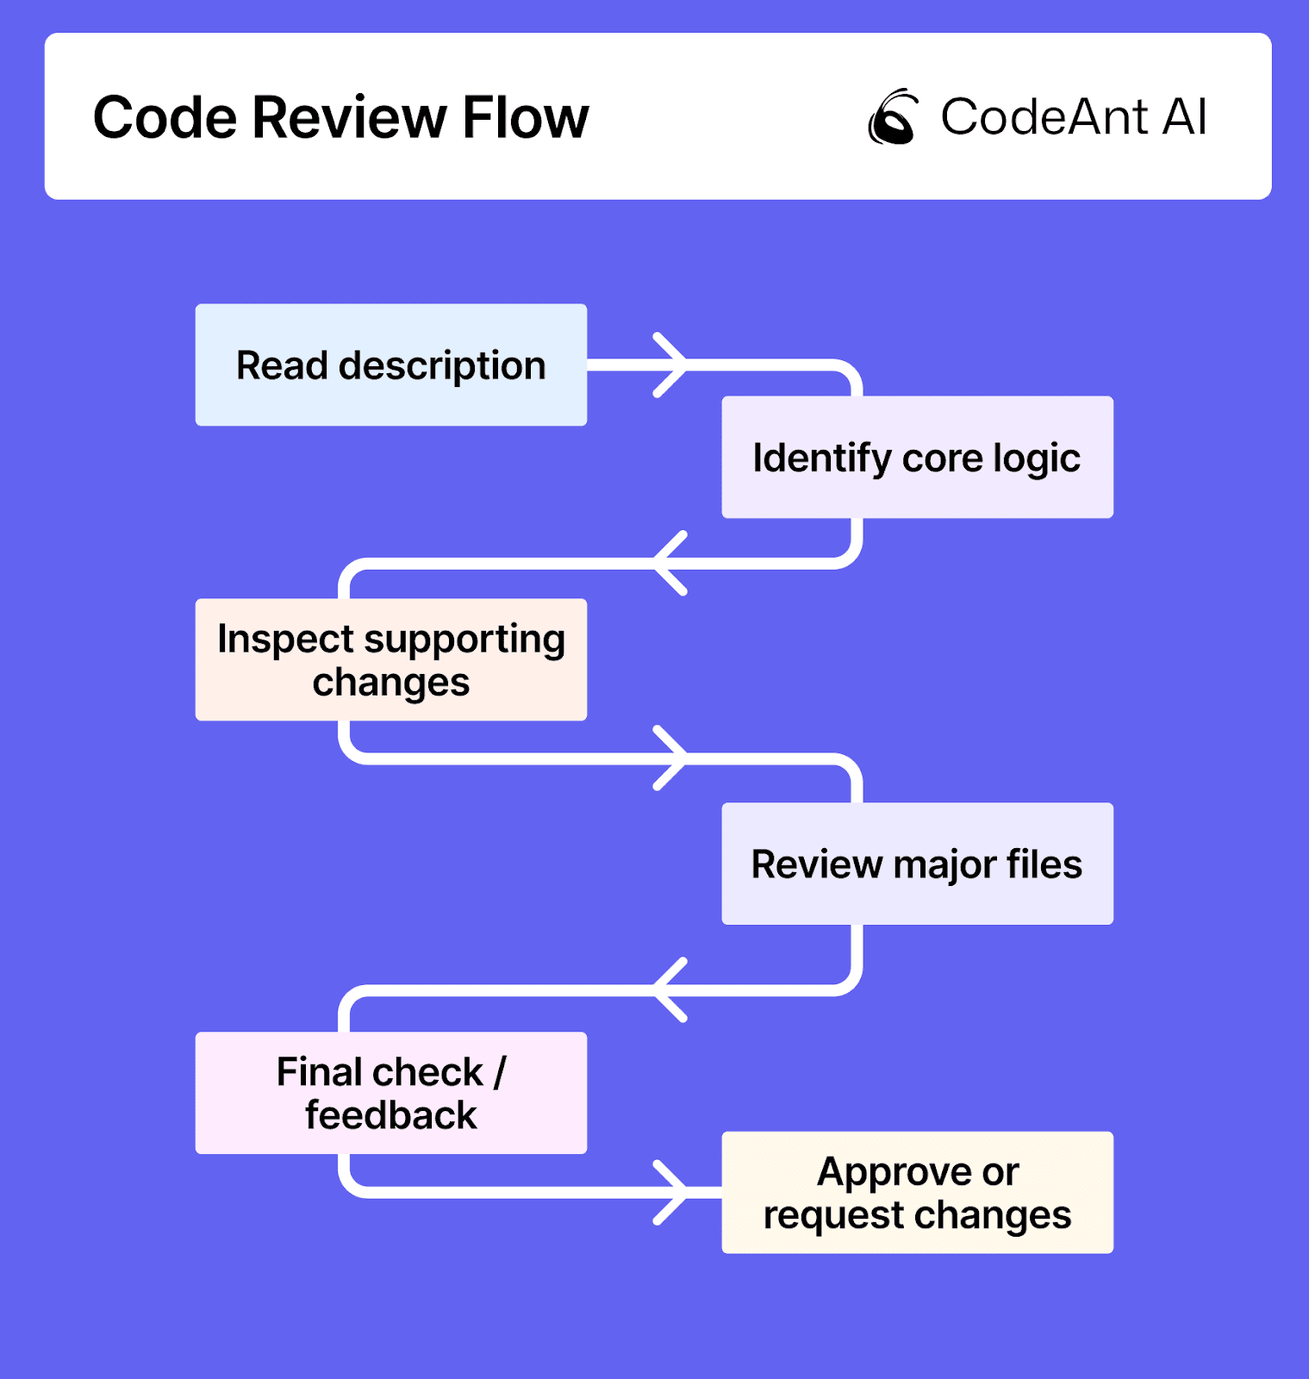
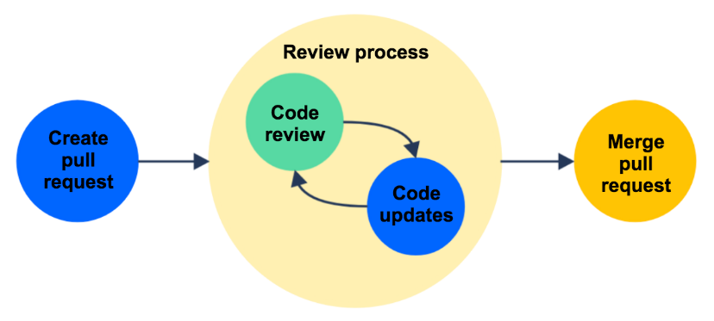
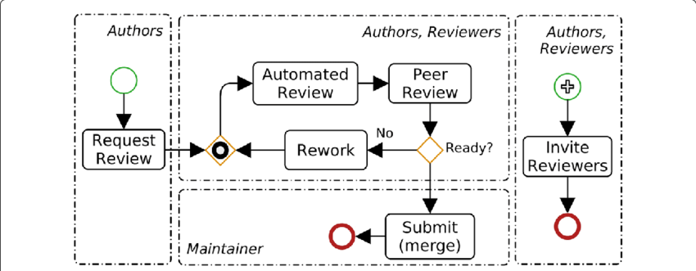
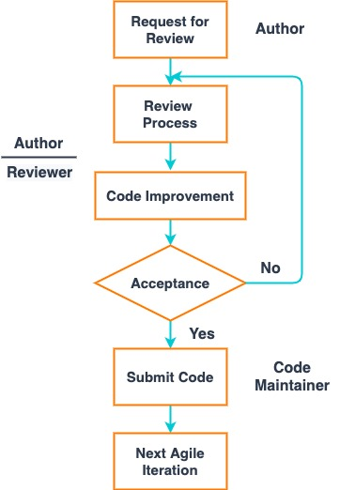

Steps
Developer → Submit PR → Reviewer checks → Comments → Fix → Approve → Merge

5.1 What to Check in Code Review
✔ Code correctness
✔ Readability
✔ Performance
✔ Security issues
✔ Proper exception handling
✔ Logging

5.2 Example Review Comments
Bad:
Fix this
Good:
Null check missing here — this may cause NullPointerException

6. Merge Strategies

6.1 Merge Commit
git merge feature/login
✔ Keeps history
❌ Creates extra commits

6.2 Rebase
git rebase main
✔ Clean history
❌ Risky if misused

6.3 Squash Merge
Combines all commits into one.
✔ Clean history
✔ Preferred in many teams

Merge Strategy Diagram
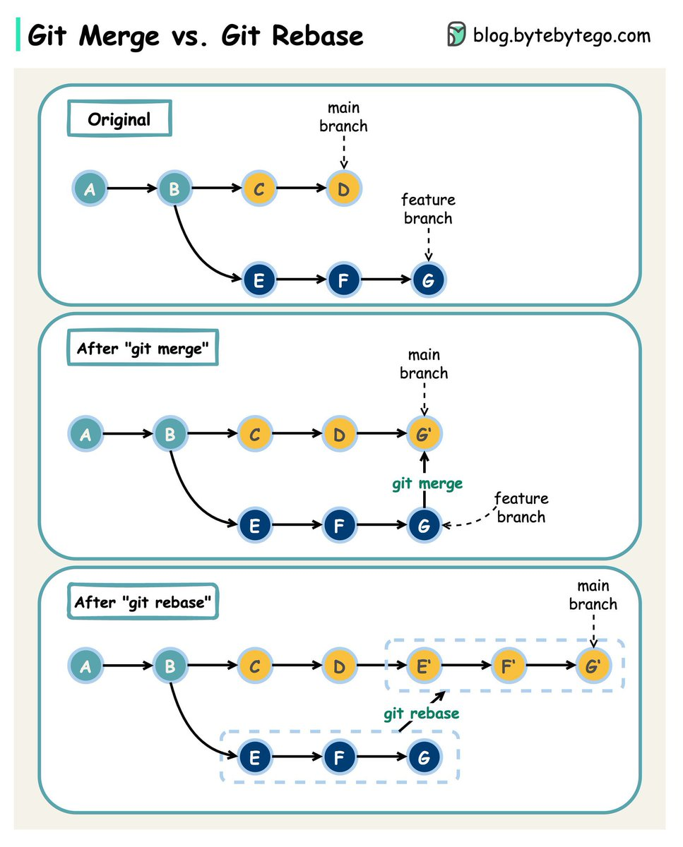
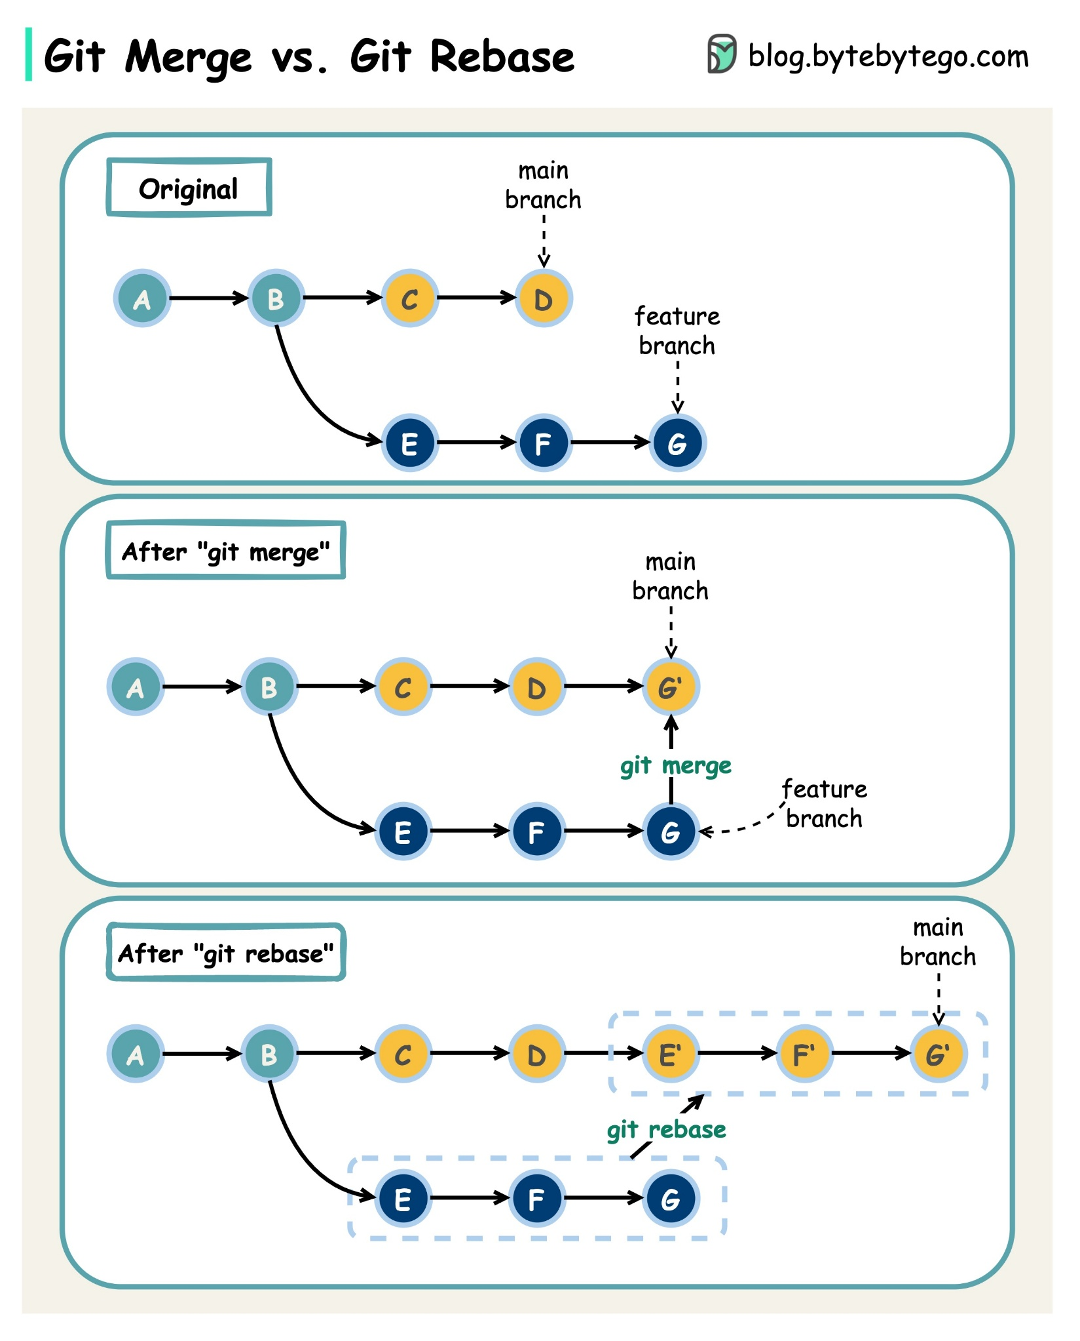
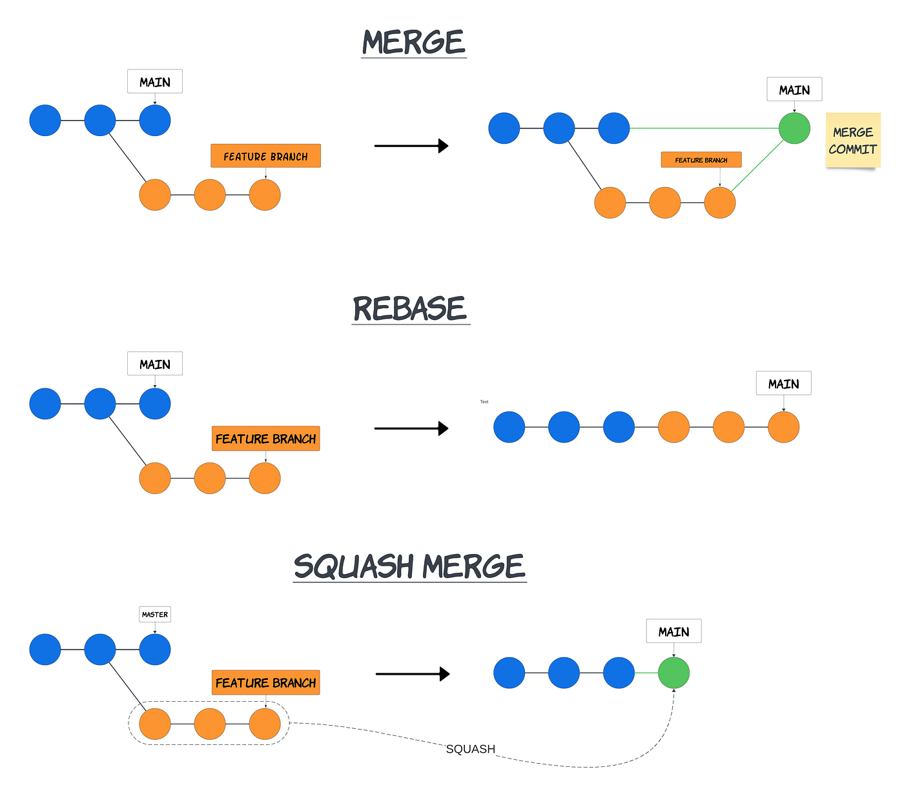

7. Real Industry Workflow (Spring Boot / Microservices)
Developer
↓
Create feature branch
↓
Write code (API / service)
↓
Push to GitHub
↓
Create Pull Request
↓
Code Review (team lead)
↓
CI/CD pipeline runs tests
↓
Merge to main
↓
Deploy to production

8. Git Commands Cheat Sheet

Branching
git branch
git checkout -b feature/login
git switch feature/login

Staging & Commit
git add .
git commit -m "Add login API"

Push & Pull
git push origin feature/login
git pull origin main

Merge
git merge feature/login

9. Common Interview Questions
- Difference between merge vs rebase
- What is Git Flow
- What is Pull Request
- What is branching strategy
- How to resolve merge conflicts
- What is HEAD in Git
- What is fast-forward merge

10. Key Takeaways
✔ Use feature branches for development
✔ Always create Pull Requests
✔ Perform code reviews before merging
✔ Follow consistent branching strategy

